SOP – Dash Navigation
To find the schedule in Dash, click on your initials in the top right corner of the screen:
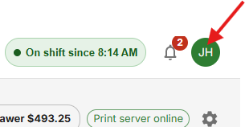

From the drop down select, “schedule”.
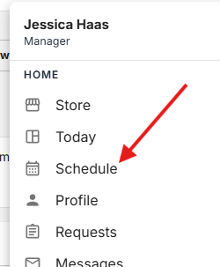

It will then bring up everyone’s schedule so you just find your name and next to that will be your scheduled shifts.
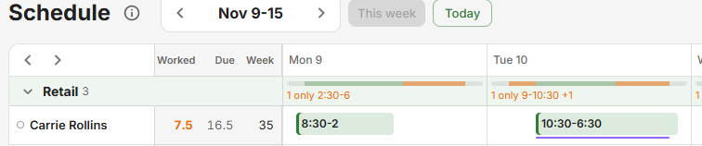
You can change weeks by clicking on the arrows at the top next to the current week’s date.


